

The Co-Active® Model

The Co-Active Model is a comprehensive tool that includes the Four Cornerstones, the Three Principles,   
the Five Contexts and Designed Alliance.

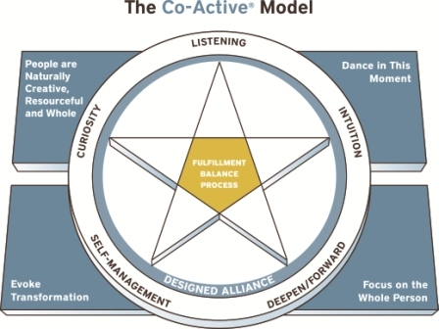

More Information is available in the document entitled The Co-Active Model in the Topic section of the Fundamentals Learning Hub.